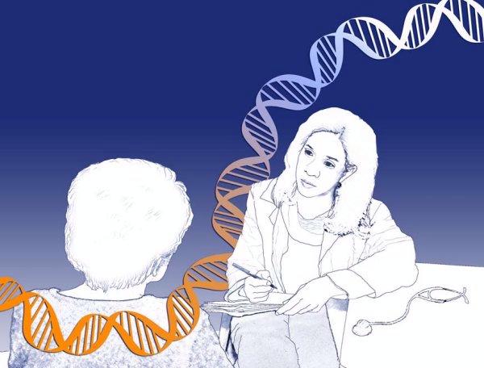
What is GINA?
The 2008 Genetic Information Nondiscrimination Act (GINA) is a federal law that protects individuals from genetic discrimination (misuse of genetic information) in health insurance and employment. Genetic information includes family health history, genetic test results, genetic counseling reports, or genetic research information. GINA was created to remove barriers to the appropriate use of genetic services by the public.
Case Example: My patient tested positive for a BRCA 1 mutation. Will this test result affect her health insurance? She is also concerned that she may lose her job if her employer finds out about these test results.
- GINA prohibits an insurer from using genetic information to make decisions about eligibility, premiums, contribution amounts or coverage terms. A health insurer cannot use family history information or genetic test results as a pre-existing condition or require that patients have a genetic test.
- Under GINA, employers cannot use genetic information to make decisions about hiring, firing, promotion, or job assignments. It is against the law for an employer to request, require, or purchase the genetic information of a potential or current employee, or his or her family members.
What are the limitations of GINA legislation?
- Does not apply to life, disability, or long-term care insurance
- Does not apply to a condition that is already diagnosed and manifest
- Not applicable for certain groups, e.g. members of the United States military (may be covered under separate policies/provisions)
Where can I go for more information about GINA?
- Genetic Information Nondiscrimination Act, www.ginahelp.org
- THD Genomics Webpage (January GINA folder)
 Click on this icon

